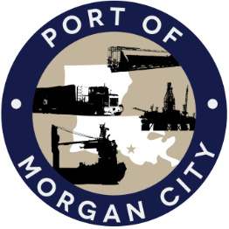

AGENDA

MORGAN CITY HARBOR AND TERMINAL DISTRICT
Regular Meeting of December 11, 2017 – 5:00 p.m. – 7327 Highway 182

1. Call to Order and Roll Call

2. Invocation and Pledge of Allegiance

3. Minutes
A. Regular Meeting of November 13, 2017

4. Finance Report
A. Presentation and discussion of financial reports for November 2017 – Deborah Garber
B. Invoices
C. Acceptance of 2016-2017 Audit by Darnell, Sikes, Gardes & Frederick, CPAs

5. Guest(s)/Public Comment
A. United States Coast Guard
B. Corps of Engineers, New Orleans District

6. Raymond “Mac” Wade - Executive Director’s Report
A. Consultant – Michael Knobloch, Knobloch Professional Services, LLC
B. Consultant – Clay Breaud, Providence/GSE
C. Consultant – Michael Lowe, GIS Engineering, LLC
D. Cindy Cutrera, Manager of Economic Development

7. Gerard Bourgeois - Legal Report

8. New Business
A. Memorial Resolution in honor of Albert Foulcard

9. Old Business
A. Discussion and any action on leasing, improvements, maintenance and repairs to facility(ies), including Coast Guard lease(s)
B. Discussion and any action regarding the U.S. Department of Homeland Security grant program, including request for proposals, bids, purchases, project management, generators, computer data system and NOAA ports system(s)
C. Discussion and any action on Government Operations and Emergency Center including bids, purchases, payments, leasing and Facility Planning and Control
D. Discussion and any action on Atchafalaya River Channel including dredging and sediment management, equipment purchases, reports, survey services, consulting services, economic study(ies), cooperative agreements with Brice Civil Contractors and the U.S. Army Corps of Engineers
E. Discussion and any action on 2016 flood fight.
F. Discussion and any action on Youngswood Site Development Project, including extension or modification of the Intermoor lease and any other related matter.

10. Election of Officers

11. Adjournment

In accordance with the Americans with Disabilities Act, if you need special assistance, please contact Tori Henry at 985-384-0850, describing the assistance that is necessary.

